WEDE5020
Web Development
Website Project Proposal
Prepared by: Neolyn Manikam
Student Number: ST10525383
Date: August 2026

Table of Contents
Website Project Proposal: Mzansi Bites Bakery (Small Business) 3
1. Organisation Overview 3
2. Website Goals and Objectives 3
3. Current Website Analysis 3
4. Proposed Website Features and Functionality 4
5. Design and User Experience 4
6. Technical Requirements 5
7. Timeline and Milestones 5
8. Budget 6
9. References 6

Website Project Proposal: Mzansi Bites Bakery (Small Business)

1. Organisation Overview
Name: Mzansi Bites Bakery
Mzansi Bites is a family-run bakery established in 2019 in Durban, specialising in traditional South African breads and pastries alongside modern celebration cakes.
Mission: To bring quality, home-style baked goods to the community using fresh, local ingredients.
Vision: To become Durban's go-to neighbourhood bakery, known for quality, warmth, and community connection.
Target Audience: Local residents, families ordering celebration cakes, and small offices ordering catering.

2. Website Goals and Objectives
- Enable online cake orders and click-and-collect pre-orders
- Increase foot traffic through improved online visibility
- Showcase the full product range with pricing
Key Performance Indicators (KPIs):
- Number of online orders placed per month
- Average order value
- Google review count and rating
- Page views on the Menu page

3. Current Website Analysis
Mzansi Bites currently only maintains an Instagram page for marketing.
Weaknesses:
- No way to place or pay for orders online
- No menu page with current prices
- Trading hours are inconsistently communicated
A dedicated website with an integrated ordering system would resolve these gaps and support growth.

4. Proposed Website Features and Functionality
- Homepage featuring bestselling products
- About Us page
- Menu/Products page with prices
- Custom cake order form
- Gallery of past cakes and products
- Contact page with location map and trading hours
- Online ordering with click-and-collect option

5. Design and User Experience
Colour Scheme: Deep chocolate brown (#4A2C17) for text and dark elements, bread-crust orange (#B5651D) as the primary accent, warm mustard (#D9A441) as a secondary accent, and soft cream (#FBF3E7) as the page background — evoking freshly baked goods, as implemented in the site's stylesheet
Typography: Playfair Display for headings (elegant), Lato for body text (clean and readable)
Layout and Design: Image-heavy CSS Grid/Flexbox layout that showcases products, with a responsive design using media query breakpoints at 820px and 560px
User experience considerations: a simple five-item navigation bar, a clear 'Order Now' call-to-action on every page, and an easy-to-scan menu with high-quality photography.
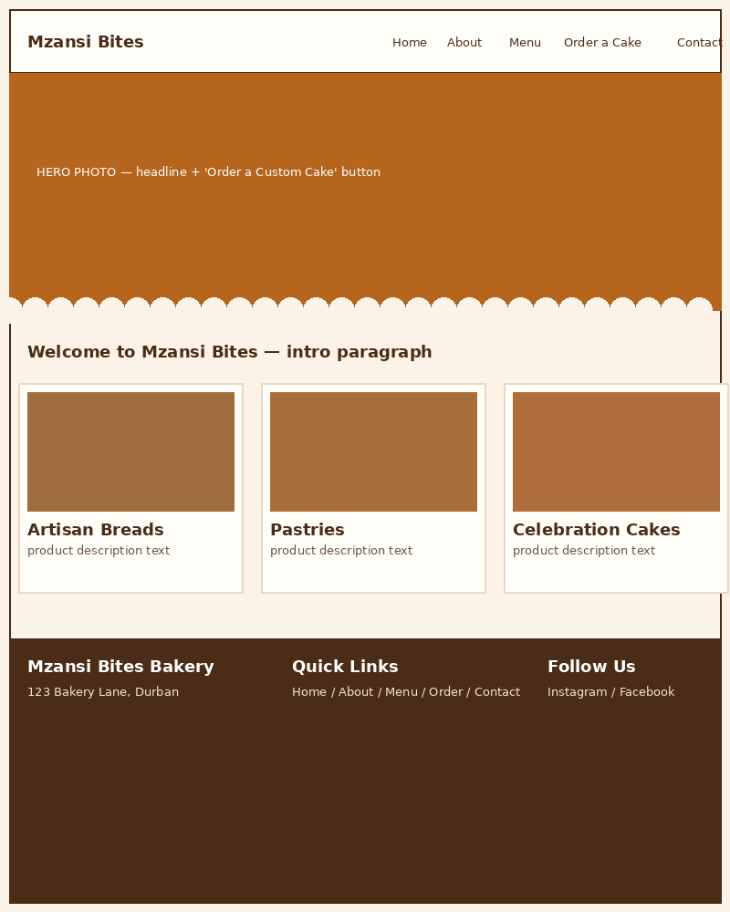
Figure 1: Homepage wireframe, updated to reflect the implemented CSS design (Part 2)

6. Technical Requirements
- Domain name: mzansibites.co.za
- Hosting: Afrihost or a Wix Business plan for integrated e-commerce
- Languages/Frameworks: HTML5, CSS3, JavaScript, with WooCommerce or Shopify for order processing

7. Timeline and Milestones
- Week 1–2: Research, requirements gathering, and wireframes
- Week 3–4: Design mockups and client feedback
- Week 5–7: Front-end and back-end development
- Week 8: Testing, revisions, and content upload
- Week 9: Launch and handover

8. Budget
- Domain and hosting: R1,800 per year
- Design and development (once-off): R7,000
- Ongoing maintenance: R450 per month
Estimated first-year total: R14,200

9. References
Afrihost, 2026. Web hosting packages. [Online] Available at: https://www.afrihost.com [Accessed 5 August 2026].
Shopify, 2026. E-commerce platform documentation. [Online] Available at: https://www.shopify.com [Accessed 5 August 2026].
Wix, 2026. Business plan features. [Online] Available at: https://www.wix.com [Accessed 5 August 2026].

